ZOLAXTECH RESEARCH HUB
HTML for Beginners
Build Your First Web Page, Step by Step
A complete, no-experience-required guide to HTML — every tag explained with a live code example, ending in one full working web page you can open in your browser today.

What's inside
- The exact structure every HTML page needs — explained line by line
- Every essential tag: headings, paragraphs, links, images, lists, tables, and forms
- A real code example for every single tag — copy, paste, and try it yourself
- Common beginner mistakes, and how to avoid them
- One full sample page, built piece by piece, with a screenshot of the finished result

Prepared by ZolaXTech · Free for students and beginners

1. What Is HTML?
HTML (HyperText Markup Language) is the language every web page is built with. It doesn't make a page pretty or interactive on its own — that's the job of CSS (styling) and JavaScript (behavior) — but HTML is the skeleton: it tells the browser what each piece of content IS. This heading is a heading. This is a paragraph. This is a link. This is a picture.
HTML works using tags — keywords wrapped in angle brackets, like <p> for a paragraph. Most tags come in pairs: an opening tag and a closing tag (with a forward slash), wrapping the content between them:
<p>This is a paragraph of text.</p>
That's really the whole idea. The rest of this guide simply introduces you to the tags you'll use most often, one at a time — and by the end, you'll combine all of them into one complete page.

2. What You Need to Get Started
- A text editor — Notepad (Windows) or TextEdit (Mac) both work, but a free code editor like Visual Studio Code makes learning much easier (it highlights tags in color and catches typos).
- A web browser — Chrome, Firefox, or Edge. You already have one; this is where you'll view your page.
- That's it — no installation, no account, and no internet connection required to build and view a basic HTML page.
✨ No software to install right now?
You can also practice at a free site like w3schools.com/html/tryit.asp, which lets you type HTML in the browser and see the result instantly, side by side.

3. The Basic Structure of Every HTML Page
Every single HTML file — no matter how simple or complex — starts with the same basic skeleton. Create a new file, save it as index.html, and type this:
<!DOCTYPE html>
<html>
<head>
<title>My First Page</title>
</head>
<body>
<h1>Hello, World!</h1>
</body>
</html>

What each line means
Tag | What It Does
<!DOCTYPE html> | Tells the browser "this is a modern HTML5 document." Always the very first line.
<html> ... </html> | Wraps the entire page — everything else goes inside this.
<head> ... </head> | Holds information about the page that isn't shown directly on the page itself, like its title.
<title> ... </title> | Sets the text shown on the browser tab.
<body> ... </body> | Holds everything visitors actually see: text, images, links, everything.
⚠ Common Mistake: Forgetting to close a tag (writing <body> but never </body>) is the #1 beginner error. Most editors highlight unclosed tags in red — always check before saving.

4. Headings and Paragraphs
Headings organize your page into sections, from most important (h1) to least important (h6). Every page should have exactly one h1 — usually the page or article title.
<h1>Main Page Title</h1>
<h2>A Major Section</h2>
<h3>A Sub-Section</h3>
<p>This is a regular paragraph of text. Browsers automatically add space before and after every paragraph.
</p>

Line Breaks and Horizontal Rules
<p>First line.<br>Second line, right below it.</p>
<hr> <!-- draws a horizontal divider line across the page -->
<br> creates a single line break inside a paragraph. <hr> draws a horizontal line to visually separate sections. Both are self-closing — they never need a separate closing tag.

5. Formatting Text
<strong>This text is bold</strong> and used to show importance.
<em>This text is italic</em> and used for emphasis.
<u>This text is underlined.</u>
✨ Use <strong> and <em> instead of the older <b> and <i> tags — they mean the same visually, but also tell screen readers (used by visually impaired visitors) that the text is genuinely important, which makes your page more accessible.

6. Links
A link (technically called an anchor) uses the <a> tag with an href attribute — short for "hypertext reference" — pointing to the destination address.
<a href="https://www.google.com">Visit Google</a>
<a href="about.html">Go to my About page</a>
<a href="mailto:me@example.com">Email me</a>

Understanding Attributes
href is called an attribute — extra information placed inside the opening tag that changes how it behaves. Attributes always follow the pattern name="value", and most tags accept several. You'll see this same pattern reused everywhere in HTML.

7. Images
Images use the self-closing <img> tag with two important attributes: src (the image's location) and alt (a text description, shown if the image fails to load, and read aloud by screen readers).
<img src="profile.jpg" alt="Photo of Selam smiling" width="200">
⚠ Common Mistake: Never skip the alt attribute. It's not optional decoration — it's what makes your page usable for people using screen readers, and it's what shows if the image link is ever broken.

8. Lists
HTML has two types of lists: unordered (bullet points) and ordered (numbered). Both wrap a series of <li> (list item) tags.

Unordered List
<ul>
<li>HTML</li>
<li>CSS</li>
<li>JavaScript</li>
</ul>

Ordered List
<ol>
<li>Learn HTML</li>
<li>Learn CSS</li>
<li>Build a project</li>
</ol>

9. Tables
Tables display information in rows and columns using <table>, <tr> (table row), <th> (header cell), and <td> (data cell).
<table>
<tr>
<th>Name</th><th>Score</th>
</tr>
<tr>
<td>Selam</td><td>95</td>
</tr>
</table>

10. Organizing a Page: Semantic Layout Tags
Beyond div (a generic container with no special meaning), HTML provides semantic tags that describe the role of each section — making your page easier to read, style, and understand for both humans and search engines.
Tag | Typical Use
<header> | The introductory area of a page — usually a title/logo and short intro.
<nav> | A group of navigation links.
<main> | The primary, unique content of the page (used once per page).
<section> | A distinct, themed grouping of content within the page.
<footer> | Closing information — copyright, contact links, credits.
<div> | A generic container with no built-in meaning, used mainly for layout/styling.

11. Forms: Collecting Input
Forms let visitors submit information. The most common pieces are <form>, <input>, <textarea>, <label>, and <button>.
<form>
<label for="name">Name:</label>
<input type="text" id="name"><br><br>
<label for="email">Email:</label>
<input type="email" id="email"><br><br>
<button type="submit">Send</button>
</form>
The for attribute on <label> should match the id attribute on its <input> — this lets clicking the label text automatically focus the correct field, which is both convenient and more accessible.

12. Comments
Comments let you leave notes in your code that browsers ignore completely — useful for reminding yourself (or teammates) what a section does.
<!-- This is a comment. It will not appear on the page. -->

13. Best Practices for Clean HTML
- Indent nested tags consistently (2 spaces is common) — it makes your structure easy to follow at a glance.
- Always close your tags, and close them in the right order (last opened, first closed).
- Use lowercase for tag names and attributes — it's the universal convention.
- Give every image a meaningful alt description.
- Use one <h1> per page, and don't skip heading levels (e.g., h2 straight to h4) just for size — use CSS for that instead.
- Save your file with a .html extension, and name your homepage index.html — most servers look for this name automatically.

14. Put It All Together: Build a Full Page
Below is one complete, valid HTML page combining everything covered in this guide — headings, paragraphs, an image, links, lists, a table, a form, and a comment. Copy this into a file named index.html, save it, and double-click the file to open it in your browser.
<!DOCTYPE html>
<html lang="en">
<head>
<meta charset="UTF-8">
<title>Selam Tesfaye - About Me</title>
</head>
<body>

<header>
<h1>Selam Tesfaye</h1>
<p>Web Design Student &amp; Aspiring Front-End Developer</p>
</header>

<nav>
<a href="#about">About</a> | <a href="#skills">Skills</a> | <a href="#contact">Contact</a>
</nav>

<hr>

<main>
<section id="about">
<h2>About Me</h2>
<img src="profile.jpg" alt="Photo of Selam Tesfaye smiling" width="140">
<p>Hello! I'm <strong>Selam</strong>, a second-year Computer
Science student in Addis Ababa, learning <em>HTML, CSS, and</em>
<em>JavaScript</em> to build my own websites.</p>
</section>

<section id="skills">
<h2>What I'm Learning</h2>
<ul>
<li>HTML - structuring web pages</li>
<li>CSS - styling and layout</li>
<li>JavaScript - interactivity</li>
</ul>
</section>

<section id="contact">
<h2>Get In Touch</h2>
<table border="1">
<tr><th>Platform</th><th>Handle</th></tr>
<tr><td>Email</td><td>selam@example.com</td></tr>
</table>

<form>
<label for="name">Name:</label>
<input type="text" id="name"><br><br>
<button type="submit">Send</button>
</form>
</section>
</main>

<!-- This comment stays invisible on the page -->

<footer>
<p>&copy; 2026 Selam Tesfaye. Built while learning HTML.</p>
</footer>

</body>
</html>

What This Page Looks Like When You Open It
Here is exactly what the code above produces when opened in a browser (with a placeholder photo in place of profile.jpg):
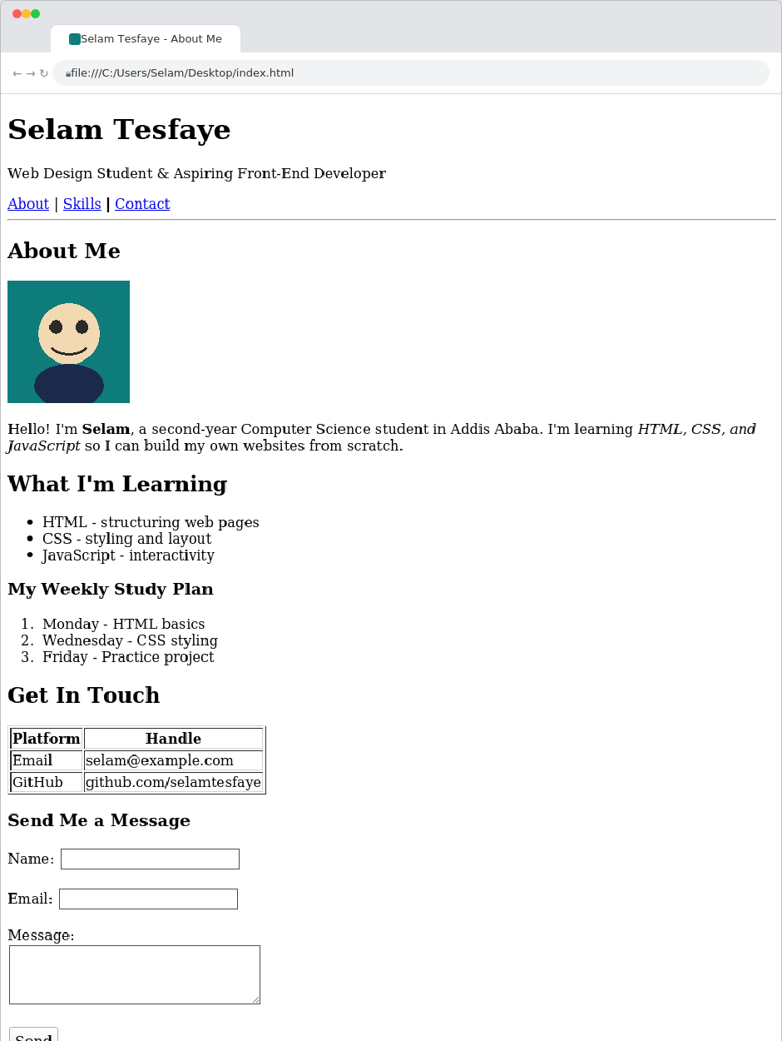

15. Common Mistakes to Avoid
- Forgetting to close a tag, or closing tags out of order (e.g., <p><strong>text</p></strong> instead of <p><strong>text</strong></p>).
- Misspelling a tag or attribute name (e.g., <imag> instead of <img>, or hraf instead of href).
- Forgetting quotation marks around attribute values (href=about.html instead of href="about.html").
- Using a heading tag just to make text bigger — use CSS for styling, and headings only for real structure.
- Leaving out alt text on images, or leaving the file's <title> as the editor's default.
- Saving the file without the .html extension, so the browser doesn't recognize it as a web page.

16. What's Next?
Once you're comfortable building pages with HTML, the natural next steps are:
- CSS (Cascading Style Sheets) — controls colors, fonts, spacing, and layout, turning a plain structural page into a designed one.
- JavaScript — adds interactivity: button clicks, form validation, animations, and dynamic content.
- Practice by rebuilding pages you like — view any website's source code (right-click > "View Page Source") to see real HTML in action.
✨ Keep this guide's final example page as a personal template — copy it, change the content, and you already have the starting structure for your next project.

This is a beginner's quick-start guide, not a complete reference. For the full list of HTML tags and attributes, the Mozilla Developer Network (developer.mozilla.org) is the most reliable free resource to consult next.
Prepared by ZolaXTech — free to download, print, and share with beginners.

